# Exercises: CSS Selectors and Rules

Problems for exercises and homework for the “HTML and CSS” course @ SoftUni. Submit your solutions in the SoftUni judge system at <https://judge.softuni.bg/Contests/405/CSS-Selectors-and-Rules>.

## The Future of Cars

You are given the HTML for the following Web page. Write the missing CSS:

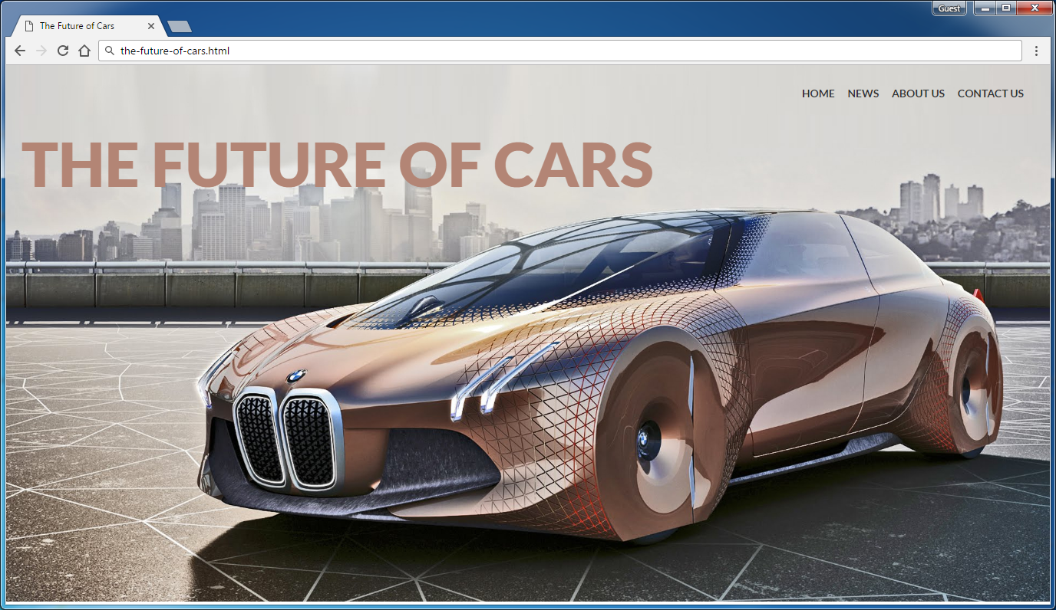

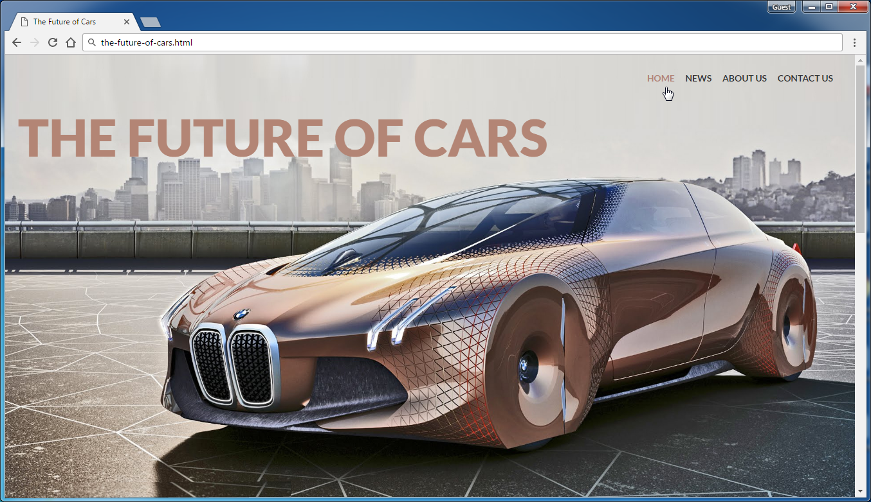

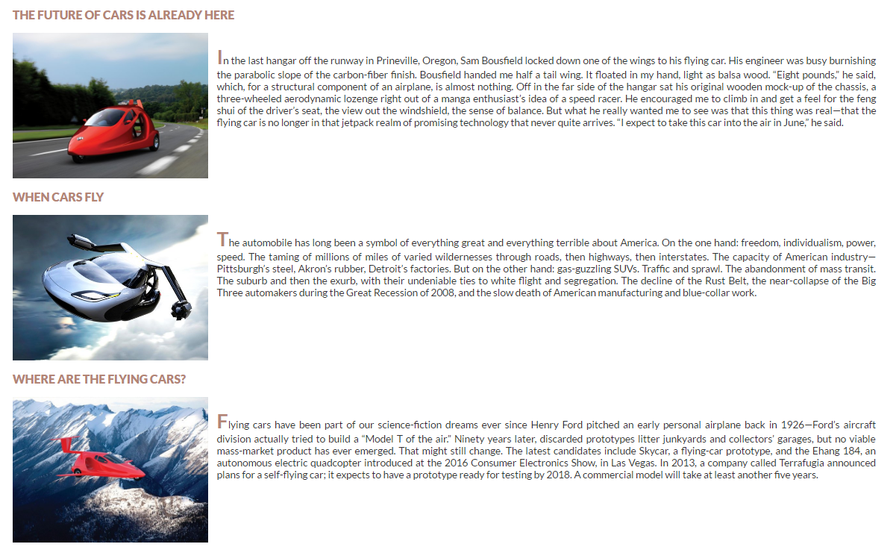

* Use the HTML file iven in the resources: "**the-future-of-cars.html**".
  + You are **NOT** allowed to change the HTML code.
* Create the CSS file and write the missing styles: "**the-future-of-cars.css**".

### Steps to Follow

Start with the **site header**:

* Copy the CSS @import for the ‘**Lato**’ **font** from Google Fonts: <https://fonts.google.com/selection?selection.family=Lato>
* <body>
  + Text font: 'Lato', sans-serif
  + Text size: 14px;
  + Text color #333333
  + Margin 0px
  + Padding 0px
* Site header
  + Background: url("*…<locate the background image>…*") no-repeat center;
  + Background Size: cover;
  + Height: 700px;
* Style the heading: <h1> in the site header
  + Text size 80px
  + Font-family: 'Lato', sans-serif;
  + Margin: 0
  + Padding 80px 0 0 20px
  + Text Weight: 900;
  + Text Color #b38575;
  + Display the text in UPPERCASE

Test the site header in the browser:

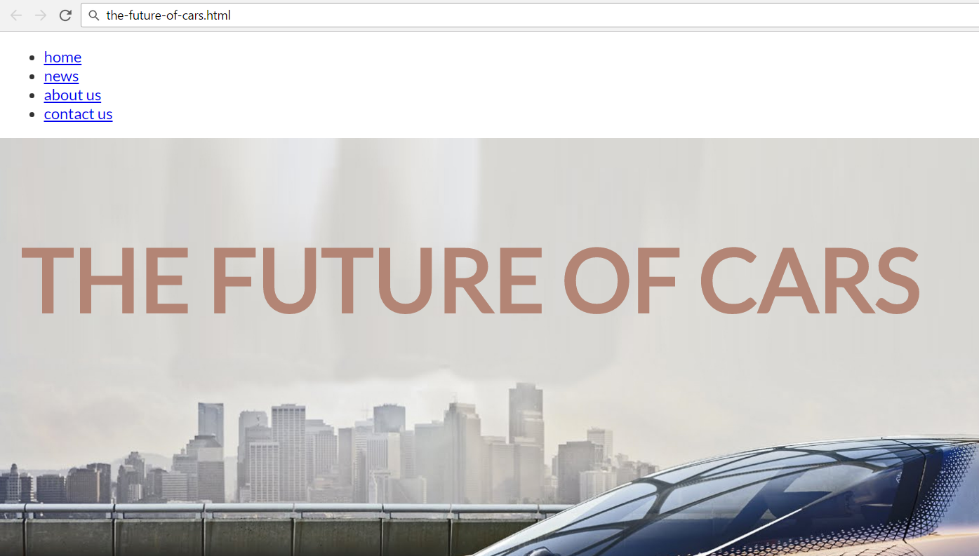

Now style the top navigation:

* <nav>
  + Margin 20px
  + Float right;
* **Unordered list in the navigation**
  + Margin 0
  + Padding 7px
  + Heigth 20px
  + Line Heigth 20px
* **List items in the navigation**
  + Display as inline blocks
* **Hyperlinks in the navigation**
  + Make them UPPERCASE
* **Hyperlinks**: a, a:link, active, visited
  + Text Color #333
  + Padding 5px 7px 10px 7px
  + Text size **1em**
  + Font Weight: bold
  + Remove text undeline
* **Hyperlinks with mouse over it**
  + Text Color #b38575

Test the site navigation in the browser:

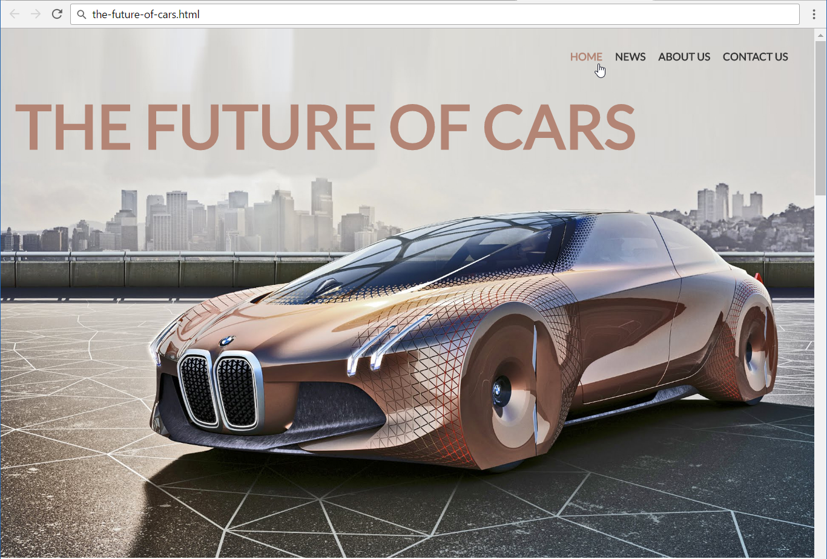

Now style the site content (articles):

* **Content section**
  + Padding Left: **25px**
  + Padding Right: **25px**
  + Center the section
  + Align Text: **Justify**
* **Articles in the content section**
  + Margin Bottom: **20px**
* **Images in the articles**
  + Width: **350px**
  + Height: **260px**
  + Margin Right: **15px**
  + Display the images on the left side (search in Google about “[CSS floating](https://www.google.com/search?q=CSS+floating)”)
* **Paragraphs in the articles**
  + Text Size: **18px**
  + Text Color: **#333333**
  + Margin: **0px**
  + Padding: **20px**
* **First letter in the first article’s paragraph**
  + Text Site: **32px**
  + Text Color: **#b38575**
  + Text Style: **bold**
  + Make the text UPPERCASE
  + **Hint**: use the pseudo-selector :first-of-type:first-letter
* **Article heading <h2>**
  + Font Weight: **900**;
  + Text Color: **#b38575**
  + Margin-Bottom: **20px**;
  + Make the text uppercase

**Test** the site content (articles section) in the browser. Note that the articles will **overlap** like shown below:

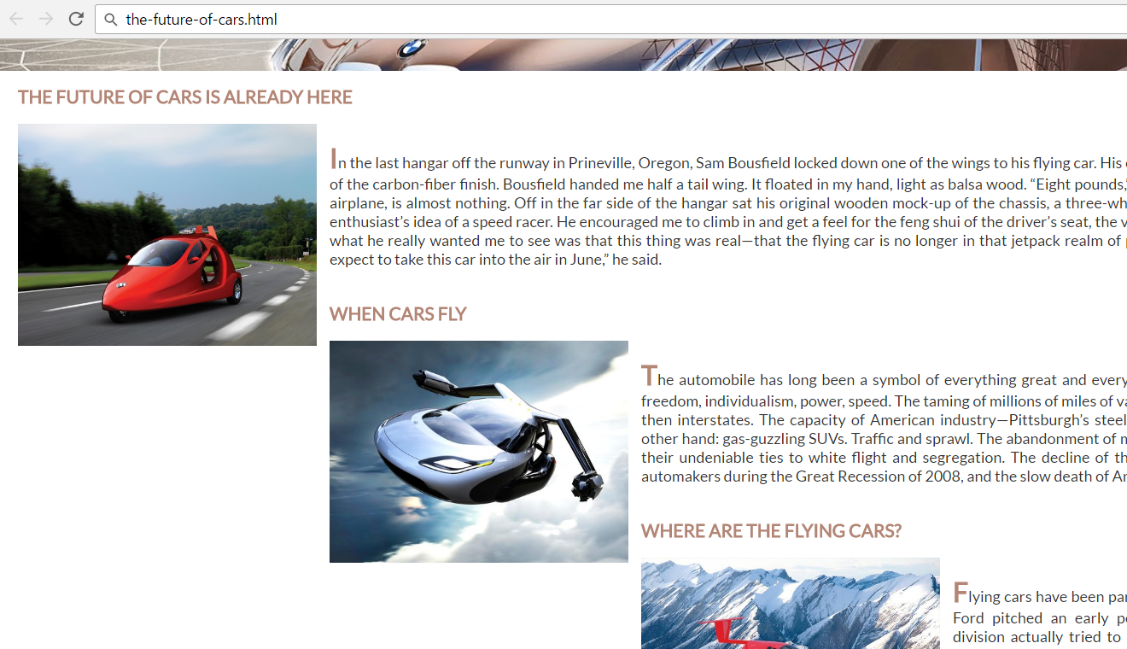

To **fix** the overlapping articles use a **“clearing” CSS** like this:

.content article:after **{**

content: '';

display: block**;**

clear: both;

**}**

Learn more about **floating and clearing** here**:** <https://css-tricks.com/all-about-floats/>.

**Test** the site content again. Now the articles should be displayed **correctly**:

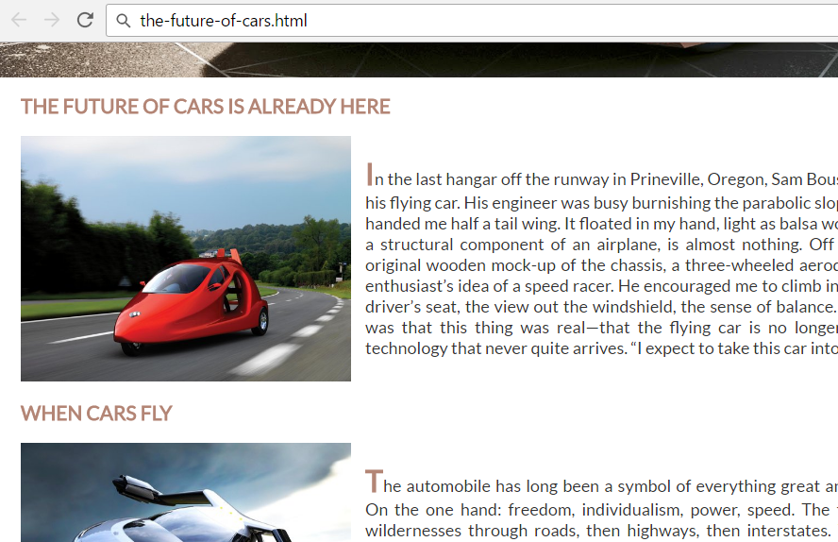

Now **style the site footer**:

* **<footer>**
  + Background Color: **#ccc**
* **<span> in the footer**
  + Center the **<span>** content
  + Display as **block** element
  + Padding: **10px**
  + Text Color: **#333333**

**Test** the site in the Web browser again:

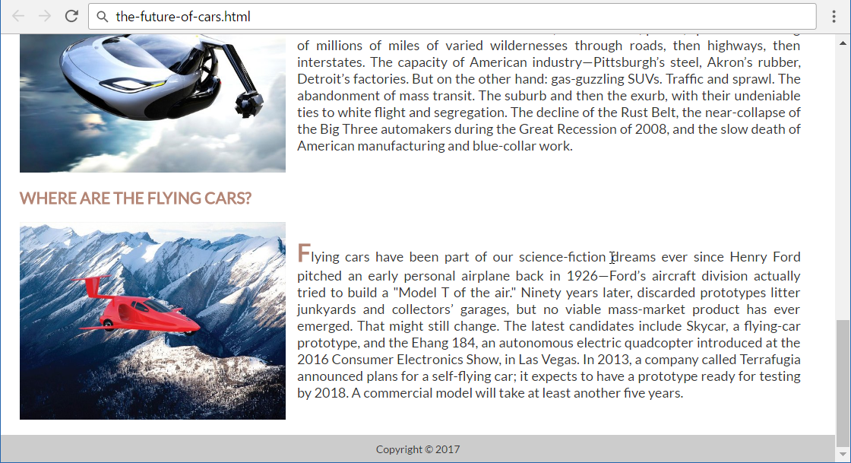

Now the site is styled completely. **Submit** your solution in the **SoftUni judge**:

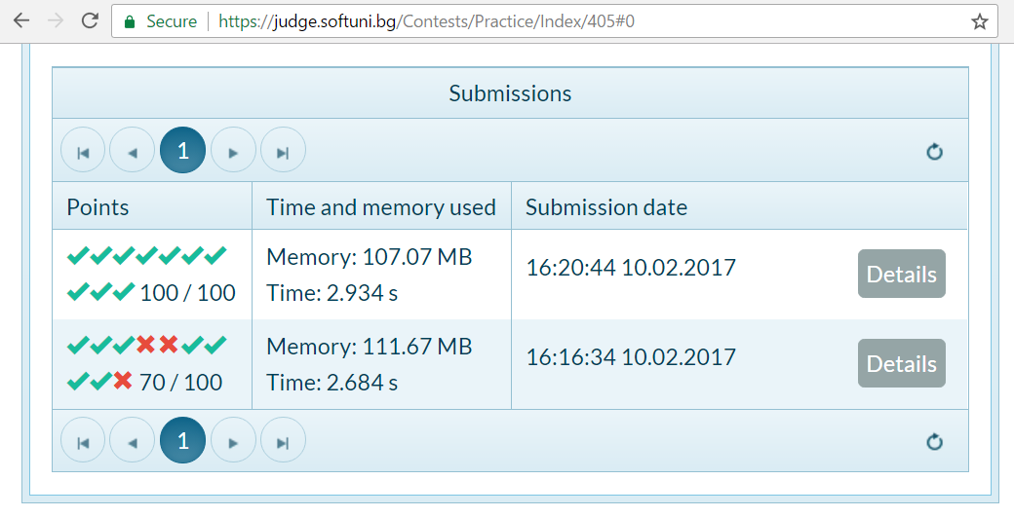

## Recipe Card

You are given the HTML for the following Web page. Write the missing CSS:

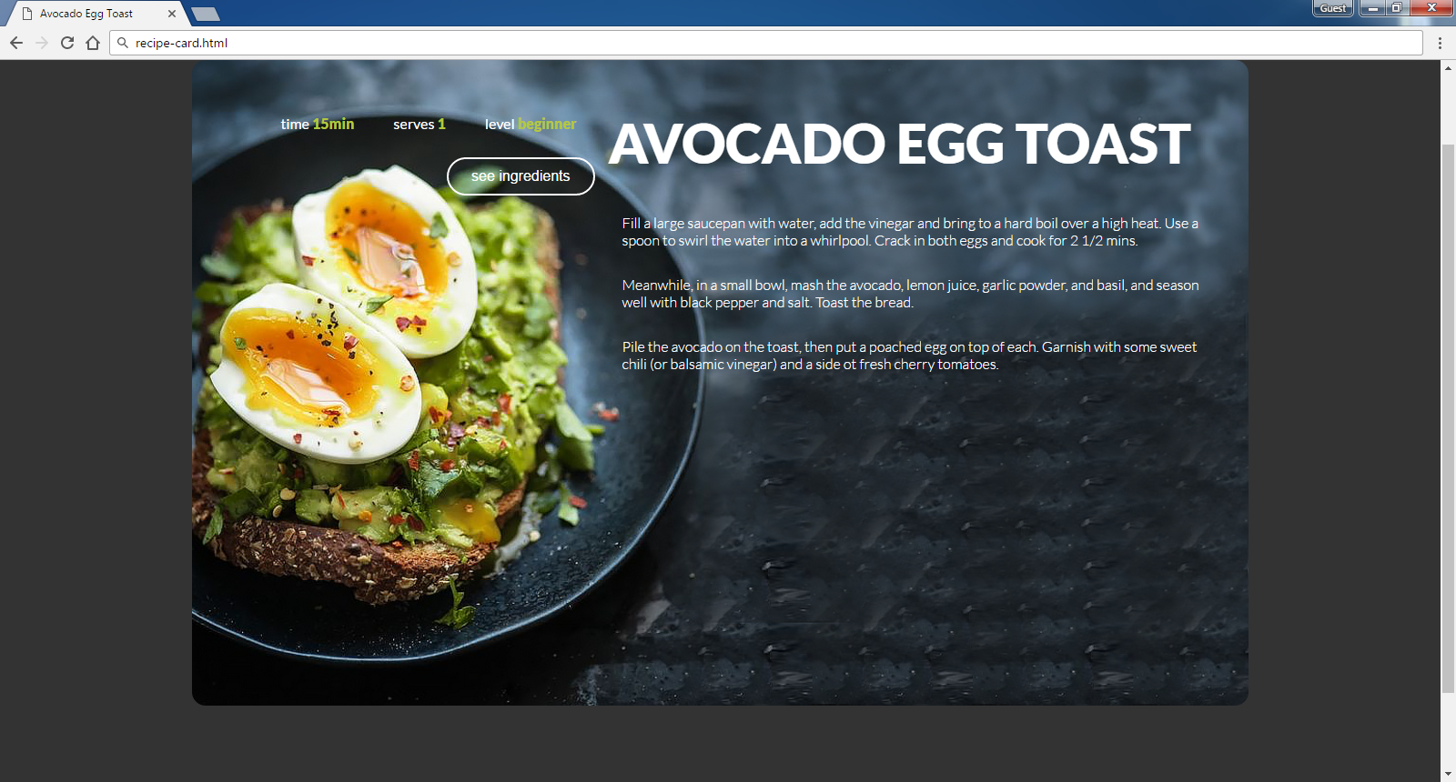

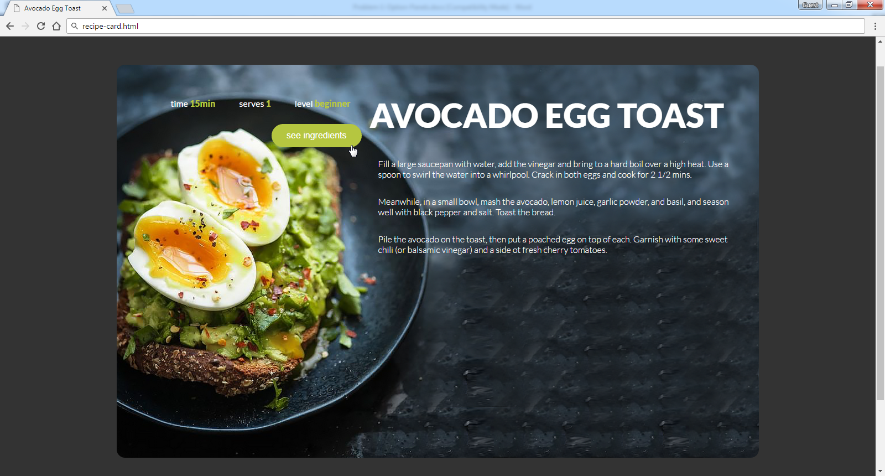

* Use the following HTML file as starting point: "**recipe-card.html**".
  + You are **NOT** allowed to change the HTML code.
* Create the CSS file: "**recipe-card.css**".

### Constraints

* Default font: 16px font-family:"Lato", sans-serif;[**"https://fonts.googleapis.com/css?family=Lato:300,400,900"**](https://fonts.googleapis.com/css?family=Lato:300,400,900)
* Default text color: #ffffff
* Text-color: #b5c640

### Hints

Use a **color picker** to catch certain colors.

1. **Color Kitchen**

Create a Web page like the shown below using the HTML coee from **"color-kitchen.html"**. Write the missing CSS.

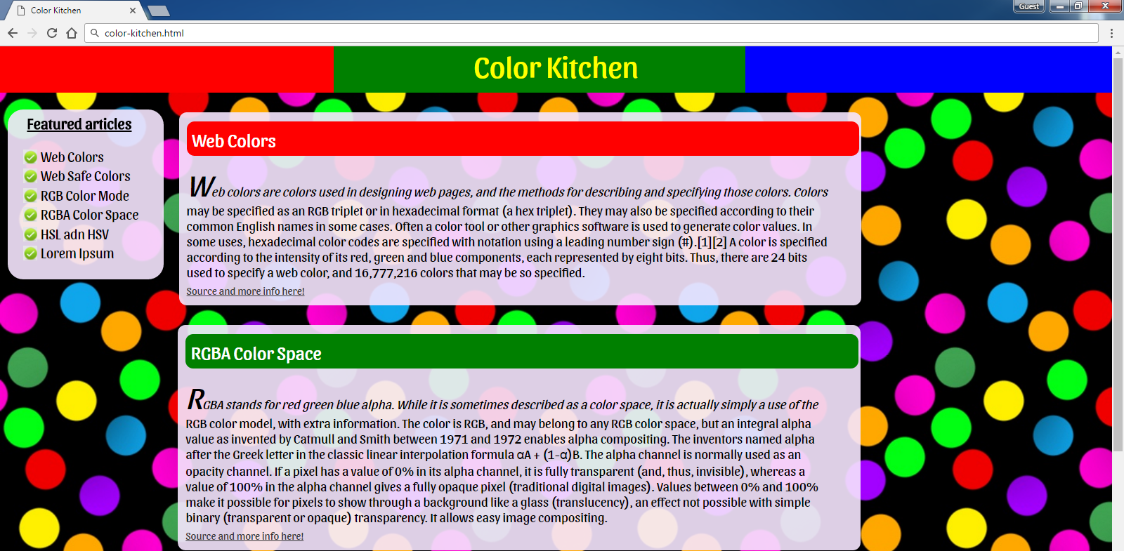 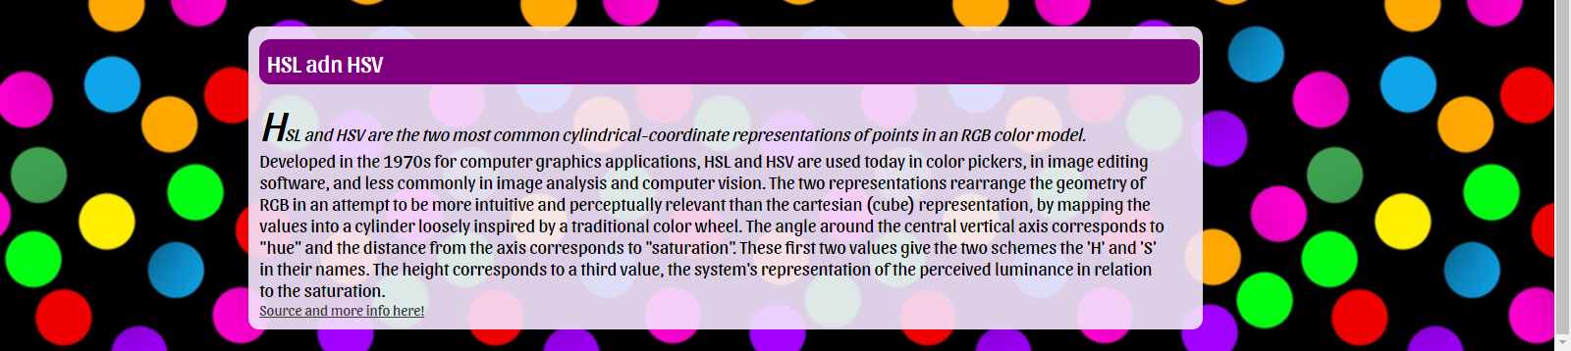

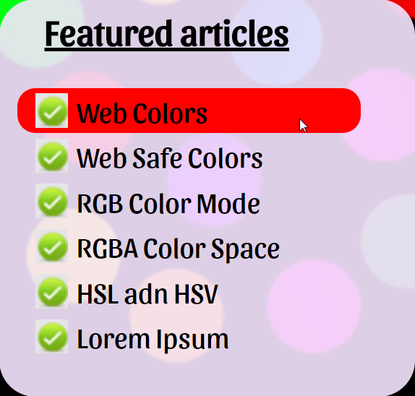 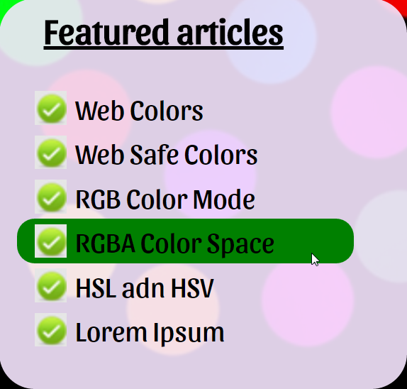

* Create the missing CSS file: "**color-kitchen.css**".
* You are **NOT** allowed to change the original HTML file.
* Default font: <https://fonts.googleapis.com/css?family=Sansita>
* Background-color: **rgba(245, 230, 254, 0.9)**
* Default: **font-size: 20px**

**Hints**

* Use **gradient generator** for header background colors (search in Internet).
* Use “rem” for specifying the font-size.

## “Plan” Page

You are given the HTML for the Web page shown below. Write the missing CSS:

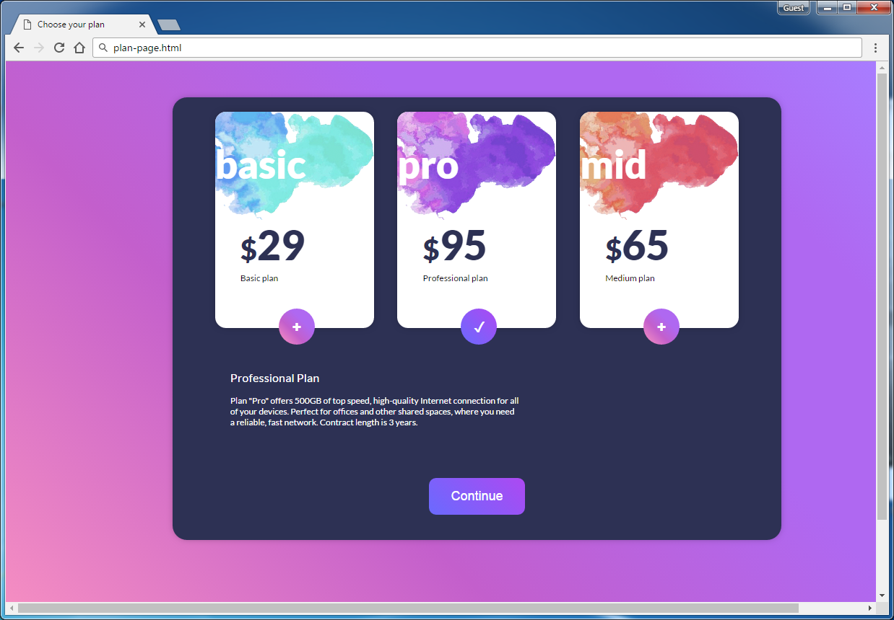

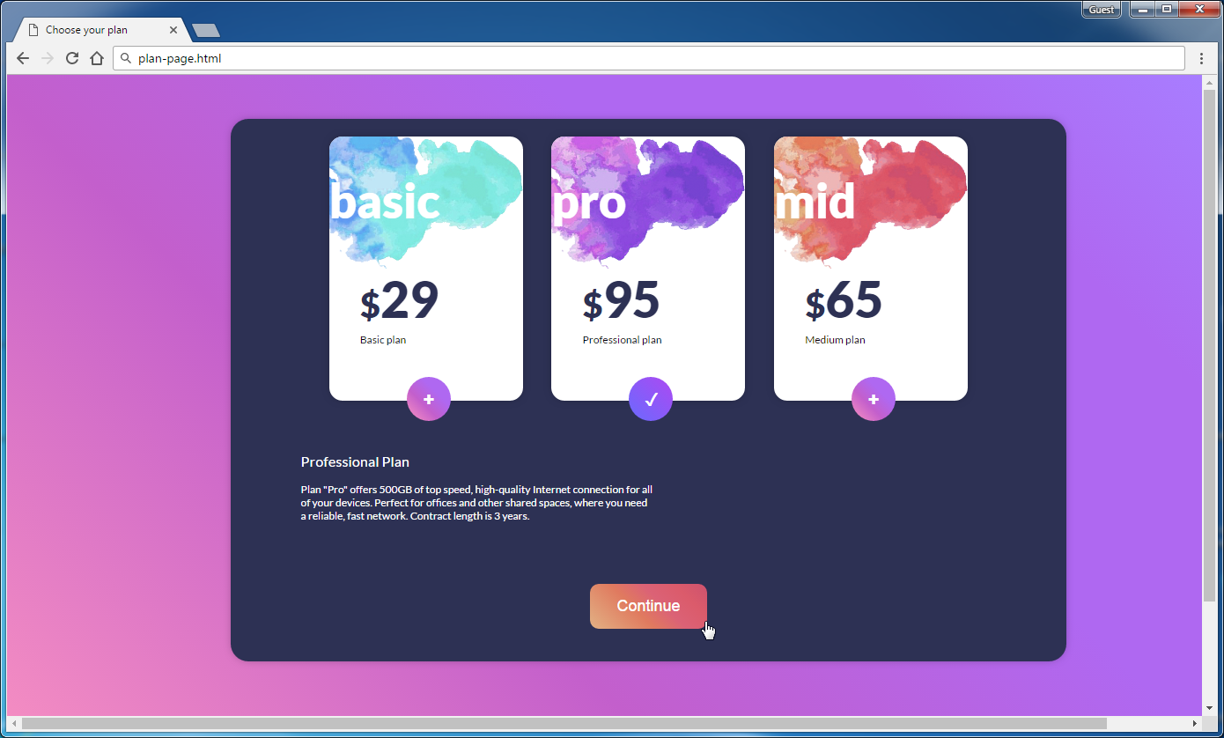

* Use the following HTML file: "plan-page.html".
  + You are **NOT** allowed to change the HTML code.
* Write the missing CSS file: "plan-page.css".

### Constraints

* As default font use “14px 'Lato', sans-serif”.
* Import the “**Lato**” font in your CSS from Google Fonts.

### Hints

Use a **color picker** to catch certain colors.

Use for <body>

* background: **linear-gradient(45deg,**

**rgba(253,149,192,1) 0%,  
 rgba(195,95,204,1) 38%,  
 rgba(175,104,241,1) 66%,** **rgba(175,104,241,1) 84%,  
 rgba(168,125,255,1) 100%);**

## Japanese Kitchen

You are given the HTML for the Web page shown below. Write the missing CSS:

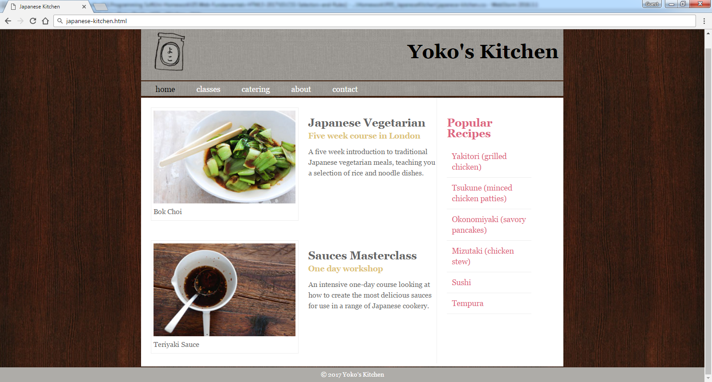

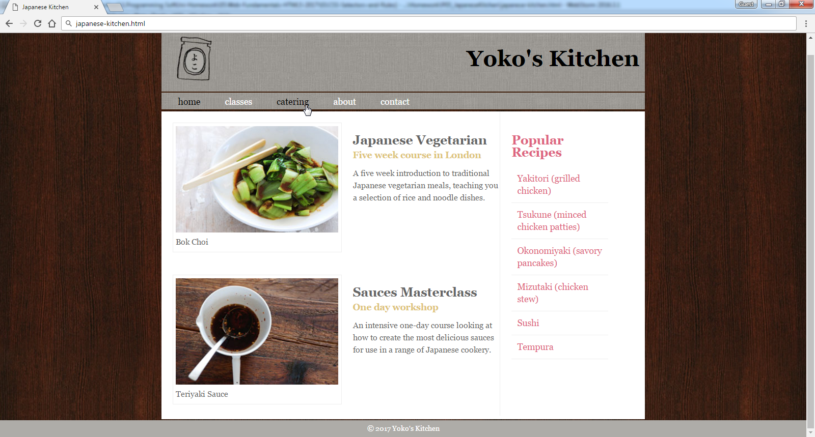

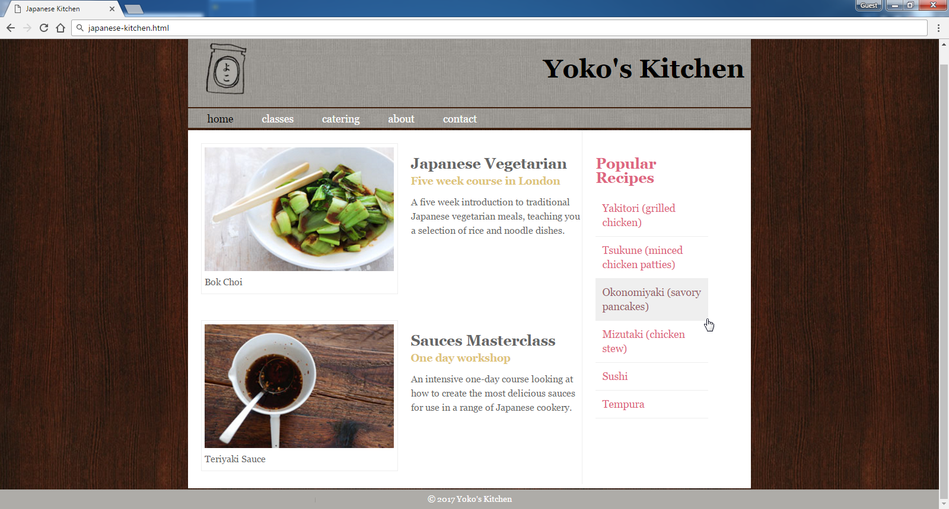

* Use the following HTML file: "japanese-kitchen.html".
  + You are **NOT** allowed to change the HTML code.
* Create the missing CSS file: "japanese-kitchen.css".

### Constraints

* **Reset** **CSS styles** at the start of your CSS.
* Default font: 14px 'Lato', sans-serif;

## Web Agency

You are given the HTML for the Web page shown below as screenshots. Write the missing CSS:





* Use the following file: "**web-agency.html**".
  + You are **NOT** allowed to change the HTML code.
* Create file: "**web-agency.css**".

### Constraints

* As default font use “16px 'Lato', sans-serif”.
* Import the “**Lato**” font in your CSS from Google Fonts.
* As default color use “#333333”.

## Potato

You are given the HTML for the following Web page. Write the missing CSS:

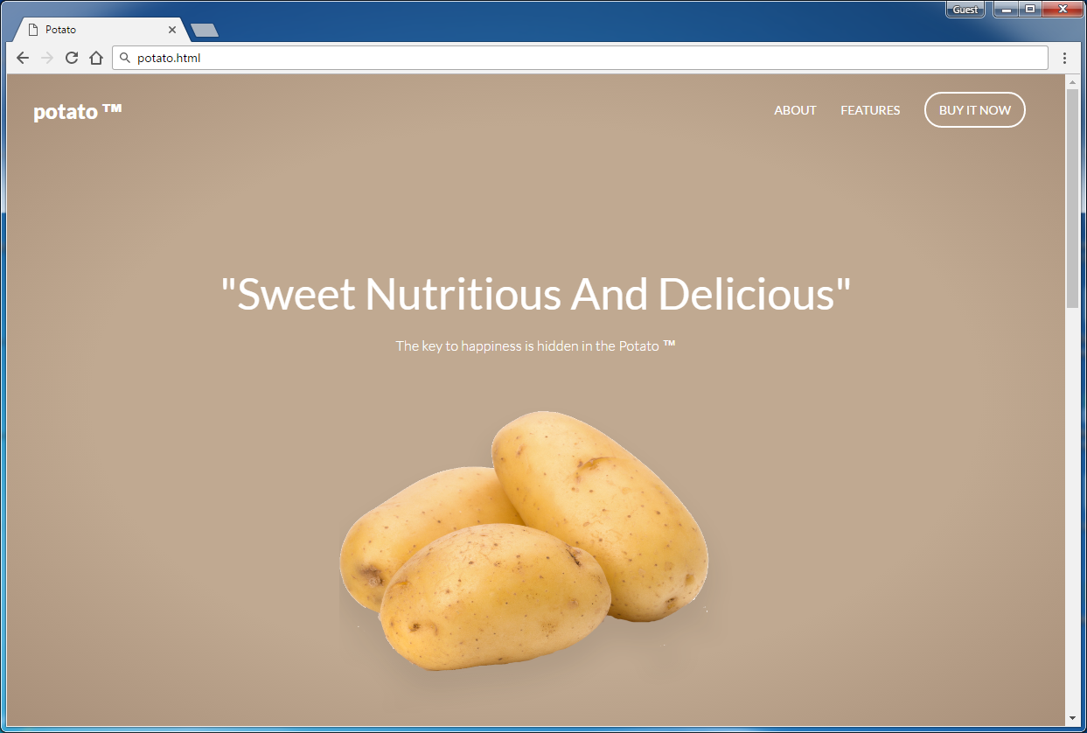

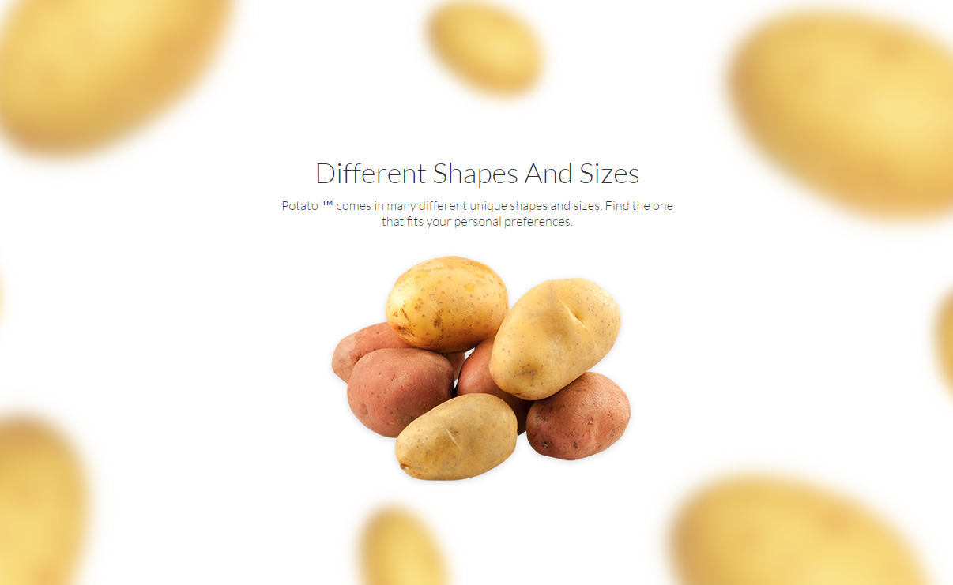

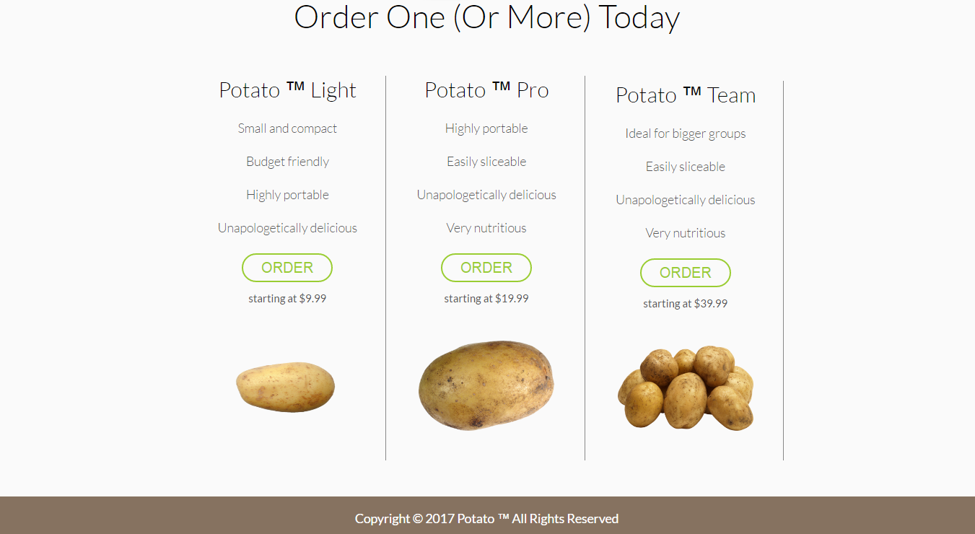

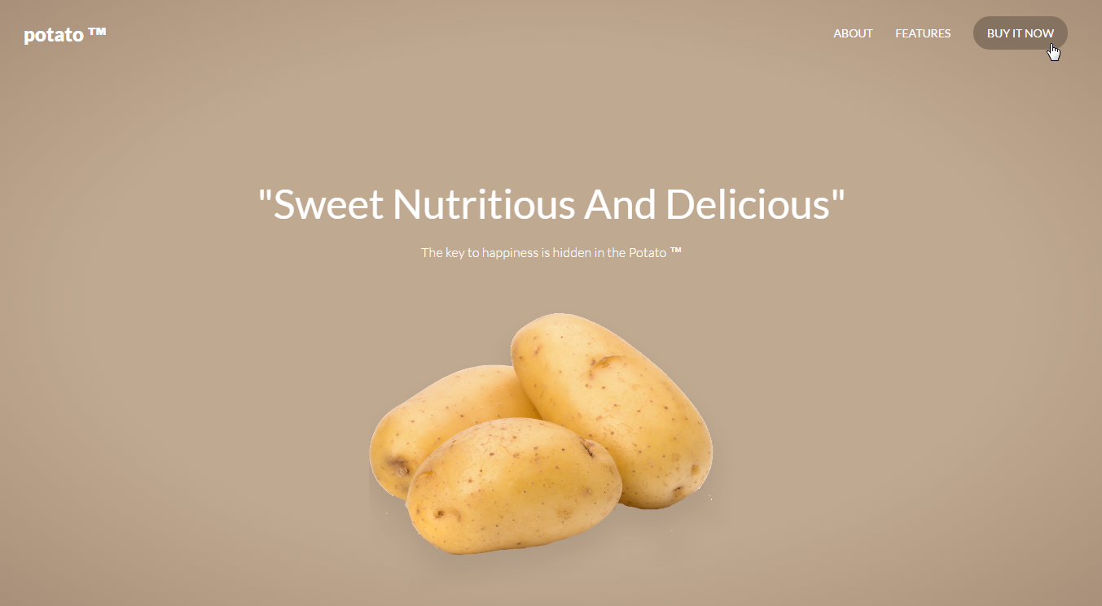

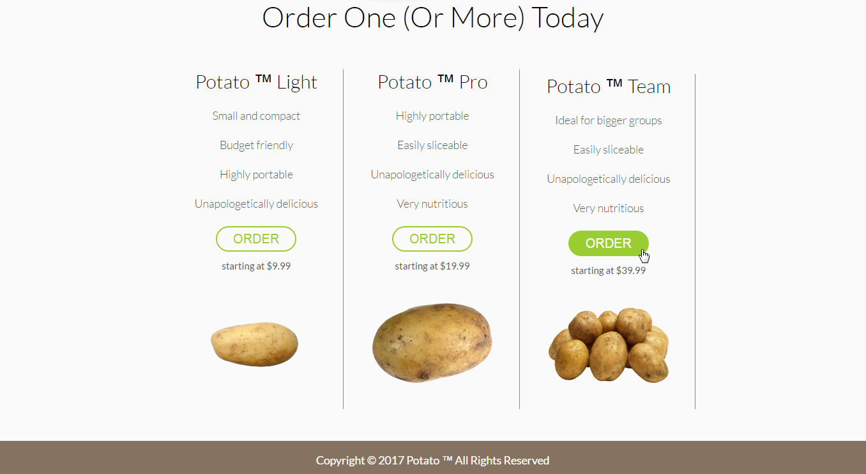

* Use the following HTML file as starting point: "**potato.html**".
  + You are **NOT** allowed to change the HTML code.
* Create the missing CSS file: "**potato.css**".

### Constraints

* Default font: 14px 'Lato', sans-serif;

### Hints

Use a **color picker** to catch certain colors.

Use for <header>

* background: **radial-gradient(ellipse at center,**

**rgba(192,169,145,1) 0%,  
 rgba(192,169,145,1) 59%,  
 rgba(168,143,121,1) 100%);**